1. **IOT BASED SMART AGRICULTURE MONITORING SYSTEM**

YEAR OF PUBLISHING : 2020

AUTHOR NAME :

* Yash Sharma
* Vishudeep Tyagi
* Priyanka Datta

ABSTRACT :

In old Days Farmers was very interested to figure out the fertility of soil and impact on feeling to grow which to quite yield. They brought some thoughts which leads to detect humidity level water level climatic condition with the help of internet of things (IOT) which is redesigning the farming sector Through the wide range of strategies, as an example accuracy furthermore as practical farming to house challenging within farming sector. The application of IOT helps in gathering of information which is quietly helpful in farming sector like changing in climatic condition fertility of soil , amount of water needed for crops , bug location interruption of creature to the sphere, horticulture, .IOT helps farmers to properutilize the technology together with the information with his residence from wherever and at whatever point. Different types of sensors are used for the inspection and control of the crop which are very significant under their precise output and use. cameras are used for remotely monitoring the field. IOT technology helps in best crop management, increase in productivity and reduce the trouble of farmer as compared to normal farming.

DESIGN METHODOLOGY /ALGORITHM:

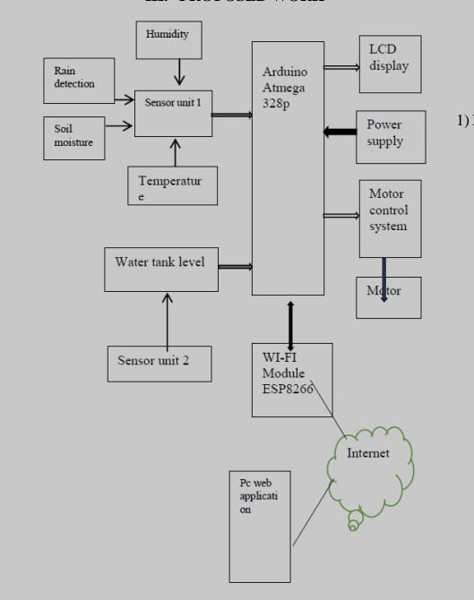

FINDING EVALUATION:

In this LM35 Temperature sensor is used instead of using RM69

ADVANTAGES:

* Advantages higher crop yield
* Prolonged production period
* Better quality
* Fewer use of protective
* Chemicals.

DISADVANTAGES:

* Installation cost high
* Often maintain the sensors

1. **Smart Agriculture System using IoT Technology**

YEAR OF PUBLISHING : 2020

AUTHOR NAME :

* Adithya Vadapalli1
* Swapna Peravali2
* Venkata Rao Dadi3

ABSTRACT :

The farming of agriculture has started past 12000 years back, Neolithic age gave birth of civilization, Farming and later being continued as traditional farming practices. India being an agrarian’s country, Mostly Indian farming are dependent on rains, soil, dampness andenvironment challenges .Our farmers upgraded tomodern state of art technology in cultivation. Globally the IoT systems has contributed its application in many fields and proven to besuccessful. It is the time that Indian farmer need to introduce the Smart Agricultural systems forhigher crop yield. The productivity with compilation of data from sensors, actuators and modern electronic gadgets the farmer can monitor agricultural fields. Smart Agriculture can forecast weather data, switching ON the pump motor acknowledging the dampness of soil terms of moisture levels with help of sensors which are interfaced to process module Arduino-UNO. The Smart agriculture system can be operated from anywhere with help of networking technology. On joining process in research and development in Smart Agriculture& Artificial Intelligencecan be cutting edge technology indata compiling and resource optimization .The pest & insectscontrols that protects damaging the crop and alsooptimisation resources utilisationcan be breakthrough.

DESIGN METHODOLOGY /ALGORITHM:

Wireless Sensor network in the process of development in smart and precision agriculture can be used to monitor regularly the changes in environmental conditions such as climate, hydrology, plant physiology, humidity, temperature, rains dampness of soil and others. As a process input, it can also demonstrate as a controller in the providing the inputs for seeds, fertilizers, pesticides etc. The WSN application shall aid the data collection process to for information needed by the farmers for cultivation and also as Input feeder control system on agricultural machinery. The failures and breakdown issues such as malfunction of sensor and power supply related issues and also the information security may be an area of concern in the Wireless Sensor

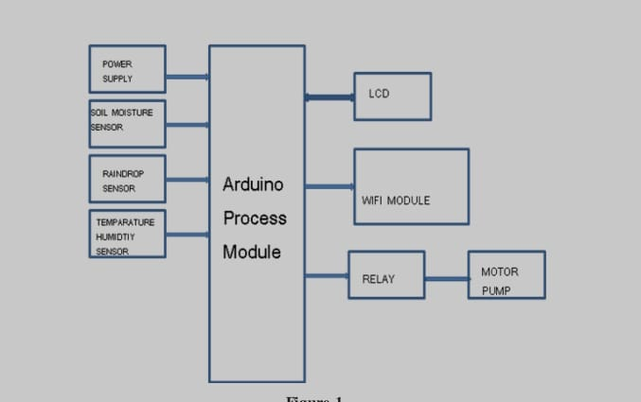

FIND IN EVALUATION:

* We will try DHT22 /AM2302 instead of DHT11.

ADVANTAGES:

* Increase the production.
* Using of sensors low cost.

DISADVANTAGES:

* Humidity and temperature accurate range is less.

1. A RESEARCH PAPER ON SMART AGRICULTURE USING IOT

YEAR OF PUBLISHING: JULY 2020

AUTHOR:

* Ritika Srivastava
* Vandana Sharma
* Vishal Jaiswal
* Sumit Raj.

Abstract :

Smart agriculture is an emerging concept, because IOT sensors are capable of providing information about agriculture fields and then act upon based on the user input. The feature of this paper includes development of a system which can monitor temperature, level of water, moisture and even the movement if any happens in the field which may destroy the crops in agricultural field through sensors using Arduino UNO board. Smart agriculture is an emerging concept, because IOT sensors are capable of providing information about agriculture fields and then act upon based on the user input. The project aims at making use of evolving technology i.e. IOT and smart agriculture using automation. Once hardware has been developed depending on the change in requirements and technology the software needs the updating. The updated hardware is called new version of the software. This new version is required to be tested in order to ensure changes that are made in the old version work correctly and it will not bring bugs in other part of the software. This is necessary because updating in one part of the hardware may bring some undesirable effects in other part of the hardware.

DESIGN METHODOLOGIES:

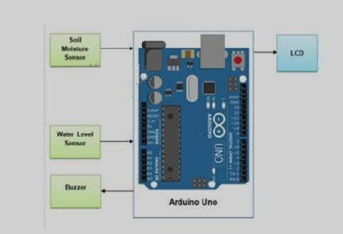

FIND IN EVALUATION:

* We can try new aurdino boards.

ADVANTAGES:

* Reduce the manpower.
* Measure level of water in field.
* Reduce time.

DISADVANTAGES:

* Remote sensing expensive to build and operate.
* Level sensor need to replace every 3 years.

1. SMART FARMING USING IOT

YEAR OF PUBLISHING : JUNE 2021

AUTHOR NAME :

* CH Nishanthi
* Dekonda Naveen
* Chiramdasu Sai Ram
* Kommineni Divya
* Rachuri Ajay Kumar

ABSTRACT:

The agriculture industry is developed a lot with the help of technology; it became data-centered and smarter. The rapid growth of the Internet of Things based technologies reshaped many industries, including agriculture. Such a radical change dismantles existing farming practices and creates new opportunities along with some challenges. The IoT systems contributed in many fields and proven. It is time for farmers need to introduce the Smart Agricultural systems for higher crop yield. With a compilation of data from sensors and modern electronic gadgets, the farmer can monitor agricultural fields. Smart Agriculture can forecast weather data, switching ON the pump motor and switch ON the bulb for artificial light due to less light intensity, for farms acknowledging the dampness of soil of moisture levels. The IR sensor detects the pest and humans by their temperature; the sensors are interfaced to process module Arduino-UNO. The Smart agriculture system can be operated from anywhere with the help of networking technology.

DESIGN METHODOLOGY:

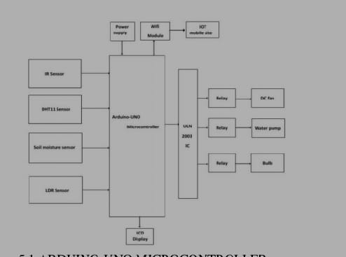

FIND EVALUATION:

* In this wifi technology is used for communication we can use zigbee for more advantages.

ADVANTAGES:

* Excellent crop yield
* Reduce the labour work

DISADVANTAGES:

* Wifi is short transmission range.